|  |  |  |  |  |  |
| --- | --- | --- | --- | --- | --- |
| **Module No:** | 1 | **IU No:** | 1 | **Exercise No.** | 1 |

|  |  |
| --- | --- |
| **Lab Assessment Statement** | **Assignment 1 - Inversion of Control**  **You are handling the Billing module of an e-commerce application. You have developed below class.**  package lithan.training.javawebapp  public class BillingService {  private PaymentProcessor paymentProcessor;    public bool completePayment() {  return paymentProcessor.process();  }  }  **Note:**   * **You are using a 3rd party library (external library) to process the payments** * **This external library provides an interface PaymentProcessor for clients to process the payments** * **The external library supports 2 modes of payment. “gpay” and “credit_card”.** * **It also has a Factory class which will instantiate appropriate processor based on mode of payment.** * **Below is the brief outline of the classes provided by external library**   public interface PaymentProcessor {  public bool process();  }  public class GooglePayProcessor implements PaymentProcessor {  public bool process() {  // process payment  return true;  }  }  public class CreditCardProcessor implements PaymentProcessor {  public bool process() {  // process payment  return true;  }  }  public PaymentProcessorFactory {  private final GooglePayProcessor gpayProcessor = new GooglePayProcessor();  private final CreditCardProcessor cardProcessor = new CreditCardProcessor ();    public PaymentProcessor getPaymentProcessor(String mode) {  if ("gpay".equalsIgnoreCase(mode)) {  return gpayProcessor;  } else if ("credit_card".equalsIgnoreCase(mode)) {  return cardProcessor ;  }  return null;  }  }     1. **Enhance the BillingService class so it gets instantiated and the dependencies shall get injected.**    * Hint: What method would you use to instantiate BillingService class? Remember, this is the bean developed by you. 2. **Write Java Configuration class to instantiate required classes from external library.** |
| **Technical Environment** | - |
| **Guidelines** | - |
| **Duration** | 120 mins |

1. **Enhance the BillingService class so it gets instantiated and the dependencies shall get injected.**
   * Hint: What method would you use to instantiate BillingService class? Remember, this is the bean developed by you.

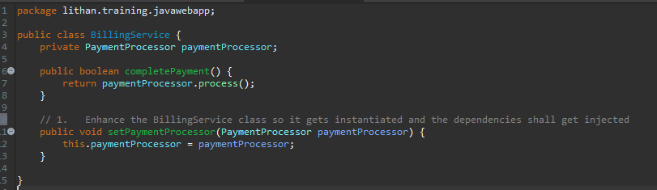

1. **Write Java Configuration class to instantiate required classes from external library.**

